Creating a Topology in ArcCatalog

1. Open ArcCatalog and navigate/connect to the ‘Topology training’ folder on your desktop, or wherever you saved it. (Alternatively, you can open the ArcCatalog plug-in within ArcMap itself and avoid opening the whole Catalog program separately.)
2. Create a new File Geodatabase inside the training folder called ‘Districts.gdb.’
3. Inside the geodatabase, create a feature dataset (a collection of feature classes, formerly known as shapefiles) called ‘Gushiegu.’
   1. Select ‘GCS_WGS_84’ as the default geographic coordinate system for the feature dataset. Click next.
   2. Leave the ‘Z’ coordinate system option blank, and click next.
   3. Leave the XY tolerance defaults, and click Finish.
4. The ‘Gushiegu’ feature dataset should appear inside the Districts.gdb. Now, we need to import the existing Gushiegu Final 1 shapefile as a feature class.
5. Right-click on the Gushiegu feature dataset, and select ‘Import.’
   1. In the ‘Input Features’ box at the top, navigate to the Gushiegu Final 1 shapefile inside the training folder. The ‘Output Location’ box should automatically populate with the path to the feature dataset you just created.
   2. Name the new feature class Gushiegu_EA, then click OK. After the tool processes, you should now see the new feature class inside the feature dataset:

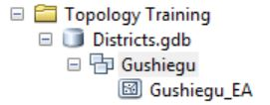

1. Now that the file structure is correct, we can create a topology. Right-click on the ‘Gushiegu’ feature dataset, and select New > Topology.
   1. Click Next, then enter a name. Leave the cluster tolerance at the default value. (Note: since the feature dataset only has a projected coordinate system, the tolerance is in decimal degrees. In the future, you should use the Ghana-specific projection and pick a cluster tolerance that is appropriate for the level of accuracy you desire.) Click next.
   2. Check the box next to ‘Gushiegu_EA’ to include it in the topology. (In the future, you can import the EA shapefile for all the districts and apply the topology rules to every file at the same time.)
   3. On the Rank screen, leave the Gushiegu_EA feature class rank as 1. The lower the number, the more important the ranking is (and less likely the geometry of the file will be changed, if errors occur). Since there are currently no other feature classes part of the topology, Gushiegu_EA is clearly the most important.
   4. On the Rule screen, click ‘add rule’ to add the topology rules that you feel are most important for the EA feature class. Some rules are only appropriate when comparing at least two feature classes- cycle through the different rules and notice when the bottom ‘feature class’ drop down becomes active:

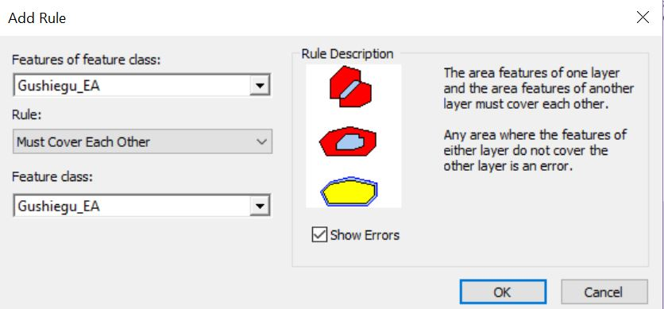

* 1. For now, let’s choose two topology rules: Must Not Have Gaps and Must not Overlap. When your Topology Rule screen looks like the screenshot below, click Next to continue, and then Finish to create the topology.

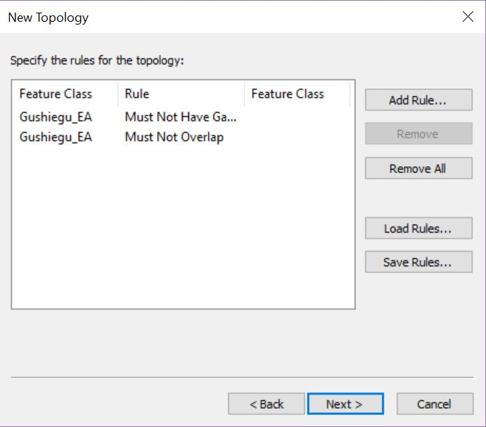

* 1. When you are prompted, click Yes to validate the topology.

1. In the Gushiegu feature dataset, you should now see a new entry for Gushiegu_Topology. Right-click to open the properties.
2. On the errors tab, click ‘generate summary’ to see how many topology errors the validation has found:

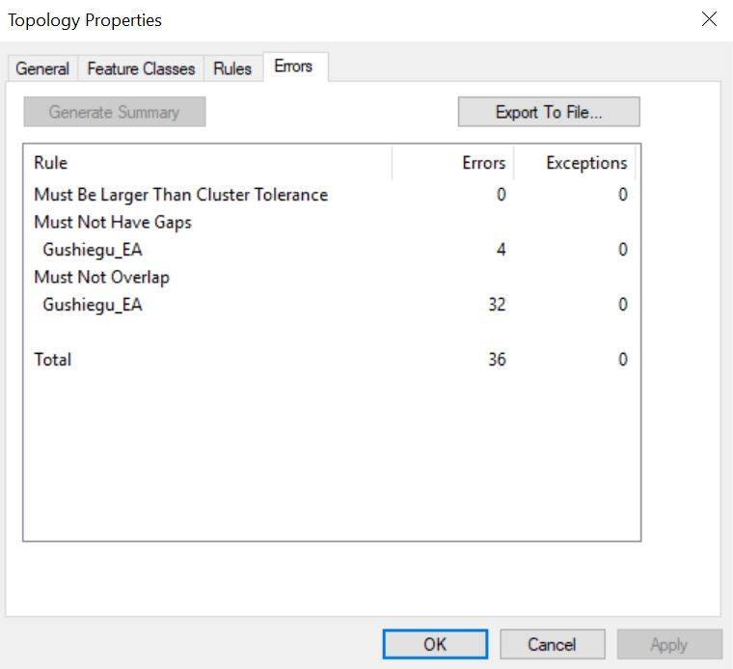

1. According to the validation summary, there are 4 gap errors and 32 overlap errors. Now, let’s move into ArcMap to visualize those problems.
2. After opening a new map display, use the ‘Add Data’ button and navigate to the Gushiegu feature class. Click the ‘Gushiegu Topology’ to add the topology to the map display (when prompted, also add all the feature classes associated with the topology).
3. The errors should be visible in red:

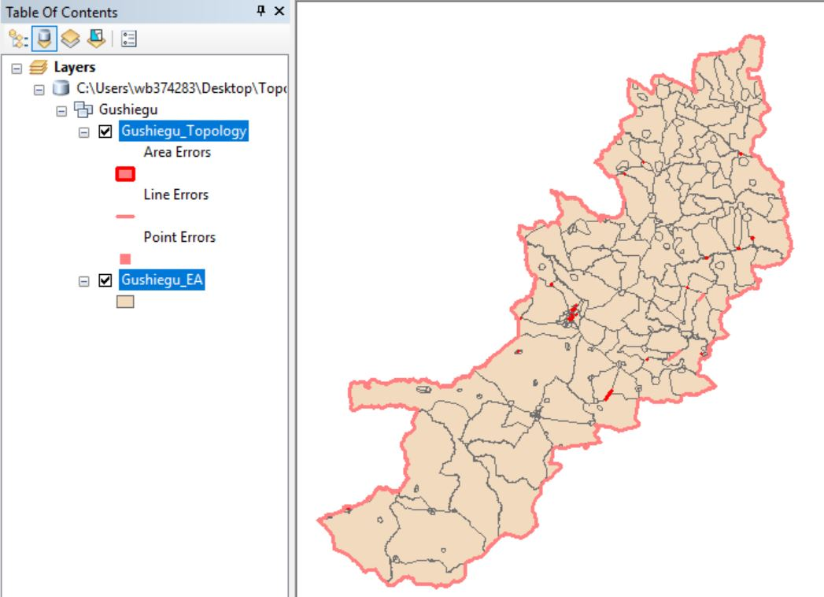

1. Now, let’s look at one of the errors closely. Zoom in to an error in the northeast (outlined in blue on the above screenshot).
2. Close up, it should look like this:

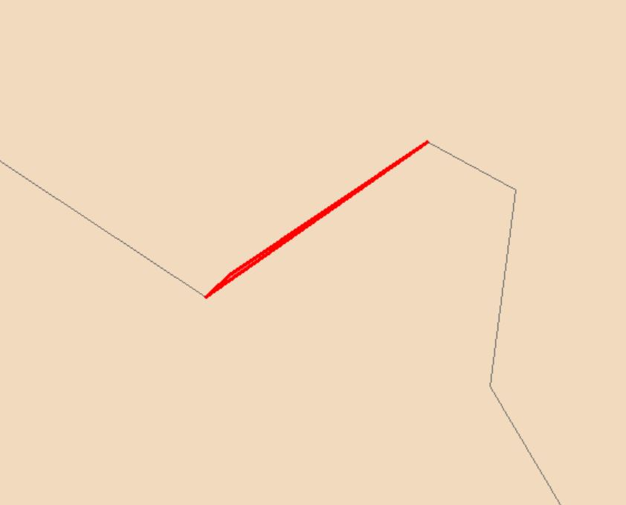

1. It looks like a sliver exists, or a overlap that occurs when the underlying vertices of two adjacent polygons don’t match correctly. To fix this, first go to Editor > Start Editing.
2. Using the Edit Vertices tool, first highlight the upper polygon, then the lower, to identify where the vertices are.

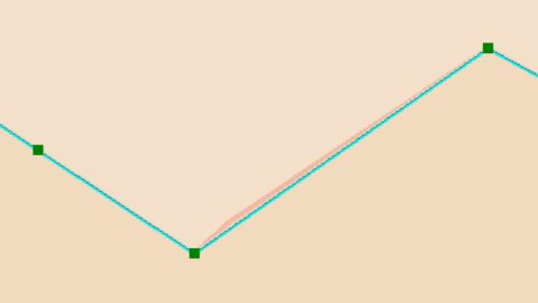

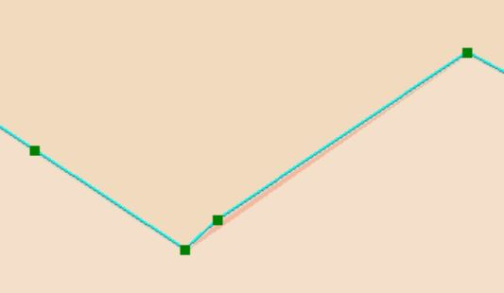

1. Notice how the lower polygon has an extra vertex. Use the delete vertex tool to remove it, and then save your edits.
2. The red error warning does not go away- in order to check that we have truly fixed it, we need to inspect the area and re-validate, using the topology tools within Arc.
3. Go to Window > toolbars > Topology to open the toolbar.



1. The button on the far right, which looks like a table, is the error inspector. This table will list all the errors within the current extent of your data frame. Right now it should be blank (because we haven’t run another validation yet).
2. Now click the ‘validate topology in current extent’ tool (third from the right, with the black checkmark).
3. Notice that the red error line disappears, and that no error listing appears in the error inspector. This means the overlap error has now been corrected.

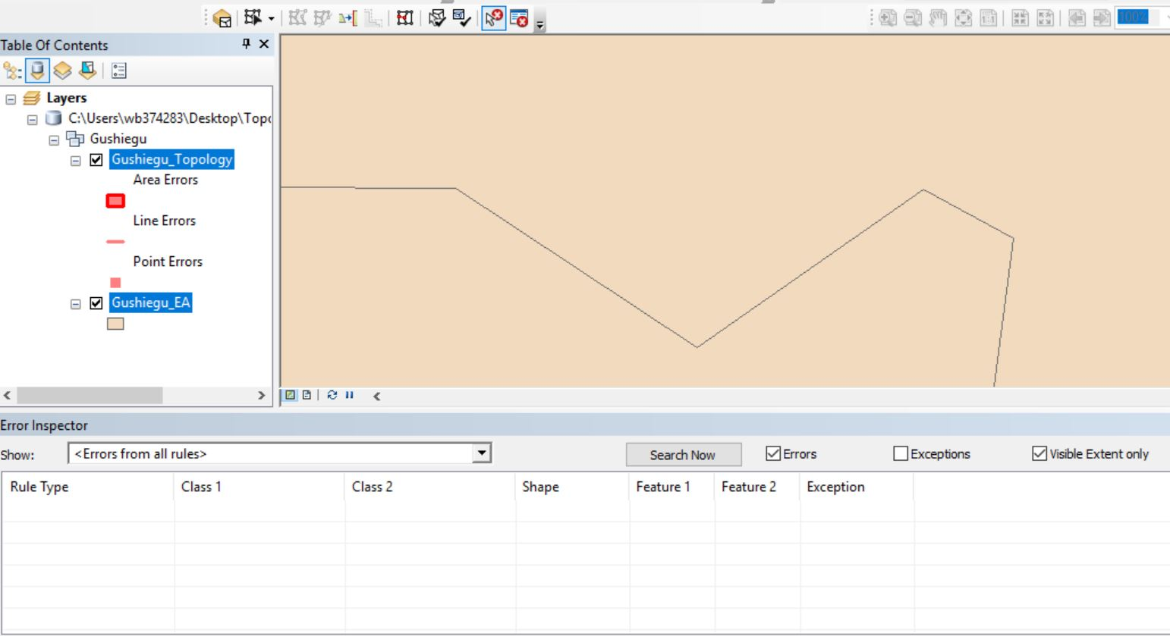

1. Zoom back to the full extent of the Gushiegu feature class, then click ‘Search Now’ on the error inspector table (in the blue box above). The table should populate with the other errors originally identified by the topology validation.
2. Zoom in and fix a few of the other errors, as time permits and until you become familiar with the topology tools. Feel free to explore some of the other tools found on the toolbar.
3. Are there any errors that should be considered exemptions? Or are they all fixable?